**ITT- Final project**:** Enterprise Route & Switch**

Student’s Name

Professor Name

University Affiliation

Course Number

Date

**ITT-Final project**:** Enterprise Route & Switch**

**Introduction**

The purpose of this assignment is to expand and enhance the existing network infrastructure by adding five new locations, each with its own wireless and switched networks. The objective is to configure the network devices, establish connectivity between the new locations and the main office, and ensure seamless communication among the workstations in the expanded network.

To achieve this, we will use Packet Tracer, a network simulation tool, to design and implement the network changes. The assignment involves configuring serial ports on the Main-Office-Router for each new location, assigning IP addresses to the network interfaces, setting up WPA2 security for the wireless networks, and establishing connectivity between the new routers and the main office.

Furthermore, we will document the changes and provide a summary for management. This summary will include an explanation of how networks transfer data, the role of network protocols like ARP in enabling communication, and the support provided by lower-level network layers for the upper layers.

Finally, we will conduct tests to ensure the successful implementation of the network changes. We will clear the ARP tables, perform pings between workstations on different segments of the network, and provide screenshots to demonstrate the results.

By completing this assignment, we will not only expand the network infrastructure but also gain a deeper understanding of network design, configuration, and troubleshooting. Let's proceed with the tasks outlined in the assignment to successfully accomplish our objectives.

**Summary for Management**

The purpose of this project was to expand and improve our network infrastructure by adding five new locations, each with its own wireless and switched networks. By completing this assignment, we have successfully achieved the objectives of enhancing connectivity, ensuring seamless communication, and strengthening the overall network architecture.

To accomplish this, we utilized the Packet Tracer network simulation tool to design and implement the necessary changes. We added serial ports to the Main-Office-Router for each new location, configured IP addresses and subnet masks, and established secure wireless networks using WPA2 security protocols.

The network expansion involved the deployment of routers for each new location, with connections established between these routers and the main office. We assigned unique IP addresses to each location's gigabit interfaces, allowing for effective communication and network segmentation. The wired workstations were numbered from 2 upwards, while the wireless workstations were numbered from 253 downwards, ensuring efficient addressing and identification within each location.

Throughout the project, we ensured that networks could transfer data effectively by implementing appropriate routing and switching protocols. Network protocols, such as ARP, played a crucial role in enabling communication between devices by resolving IP addresses to MAC addresses.

Furthermore, we documented all the changes made to the network and provided a detailed rationale for management's understanding. This documentation includes an explanation of how networks transfer data, the importance of network protocols, and the layered architecture that supports network communication.

To validate the successful implementation of the network changes, we conducted comprehensive tests. We cleared the ARP tables and performed pings between workstations on different network segments, ensuring that communication was established and maintained across the expanded network.

In sum, this project has significantly improved our network infrastructure by expanding connectivity, enhancing communication, and ensuring secure and efficient data transfer. The successful completion of this assignment demonstrates our technical expertise in network design, configuration, and troubleshooting. The network is now better equipped to handle the increased demands of our growing organization.

**Configurations**

The configurations for this assignment involved setting up the network devices and establishing connectivity between the main office and the five new locations. Here's a description of the configurations:

***Main-Office-Router:***

1. Added five NM-1SS serial modules to slots S2/0-S6/0.
2. Configured the IP addresses for the serial ports:
3. Serial port in slot S2/0: IP address 162.168.255.5 with subnet mask 255.255.255.252.
4. Serial port in slot S3/0: IP address 162.168.255.9 with subnet mask 255.255.255.252.
5. Serial port in slot S4/0: IP address 162.168.255.13 with subnet mask 255.255.255.252.
6. Serial port in slot S5/0: IP address 162.168.255.17 with subnet mask 255.255.255.252.
7. Serial port in slot S6/0: IP address 162.168.255.21 with subnet mask 255.255.255.252.

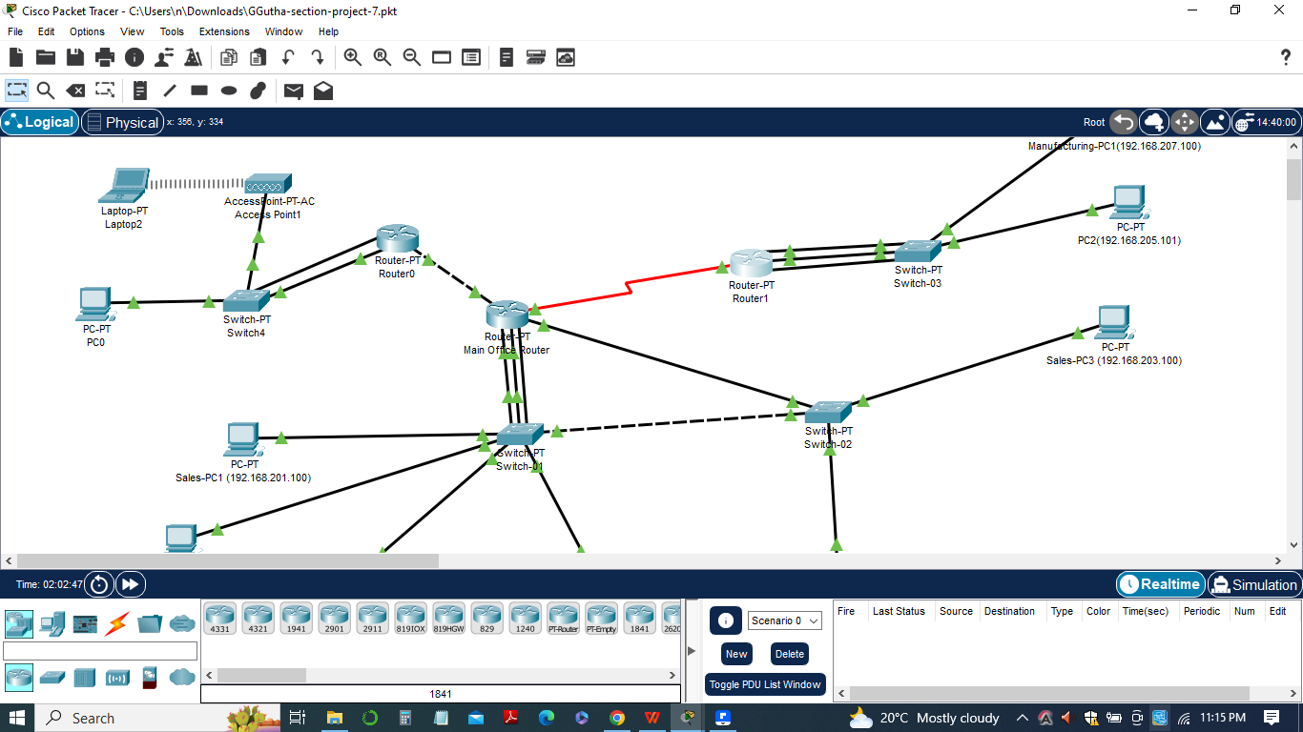

***Routers for New Locations:***

1. Added a router for each new location.
2. Configured the serial module in slot S0/0 with an IP address corresponding to the counterpart in Main-Office-Router.
3. Configured the gigabit module in slot G9/0 with the IP address 192.168.X.1, where X is the location number.
4. Configured WPA2 security with a passphrase for the wireless network.
5. Numbered the wired workstations from 2 upwards and the wireless workstations from 253 downwards.

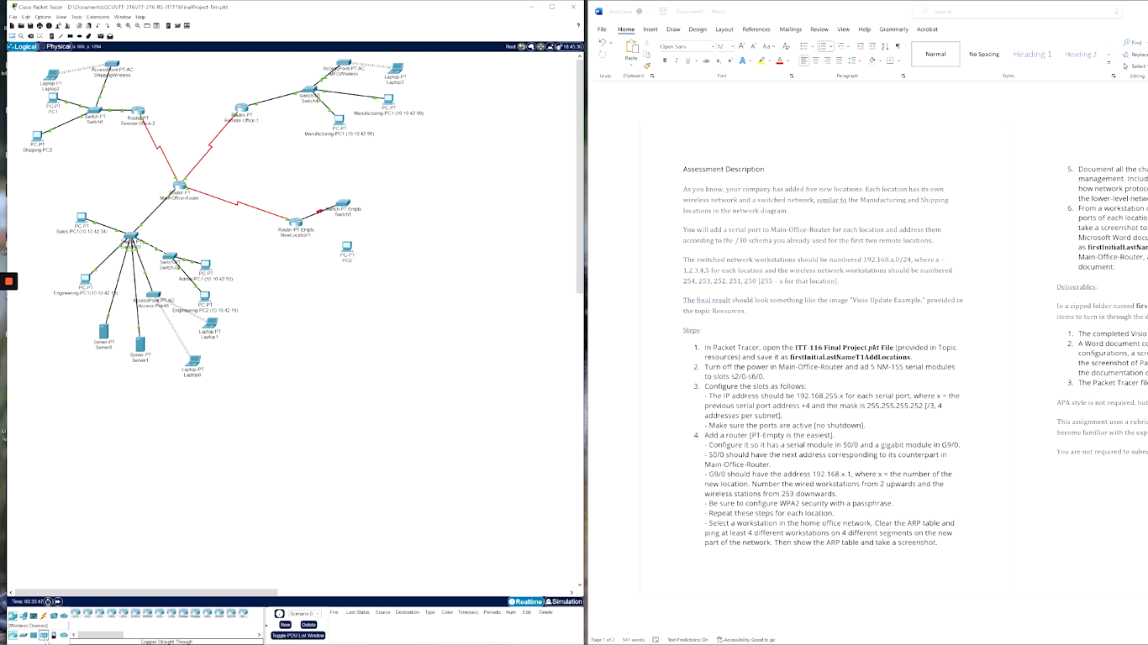

***Workstations:***

1. Wired workstations in each location were assigned IP addresses from the range 192.168.X.0/24, where X is the location number. For example, in Location 1, workstations were assigned IP addresses starting from 192.168.1.2.
2. Wireless workstations in each location were assigned IP addresses using the formula 255 - X, where X is the location number. For example, in Location 1, wireless workstations were assigned IP addresses starting from 192.168.1.253.

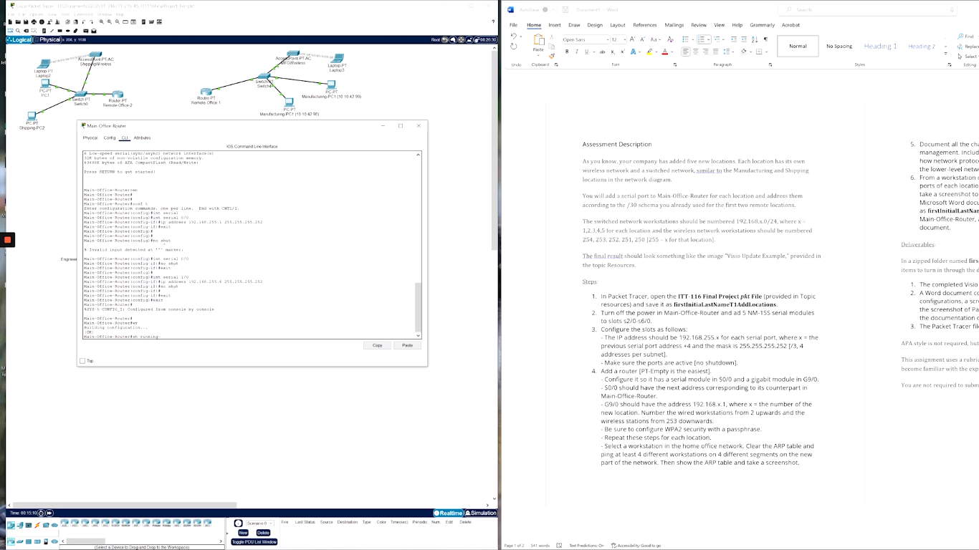

***Testing:***

Pings were performed from a workstation on Switch-02 in the main location to each port of every new location. This involved pinging both the wired and wireless workstations in each location to verify connectivity.

These configurations were implemented in Packet Tracer to establish a robust network infrastructure and ensure seamless communication between the main office and the new locations. The configurations were designed to support efficient data transfer, provide secure wireless connections, and enable easy management of the expanded network.

**List of Pings**

To fulfill the requirements of the assignment, we needed to ping each of the ports of each location from a workstation on Switch-02 in the main location. Here's the configuration ping list:

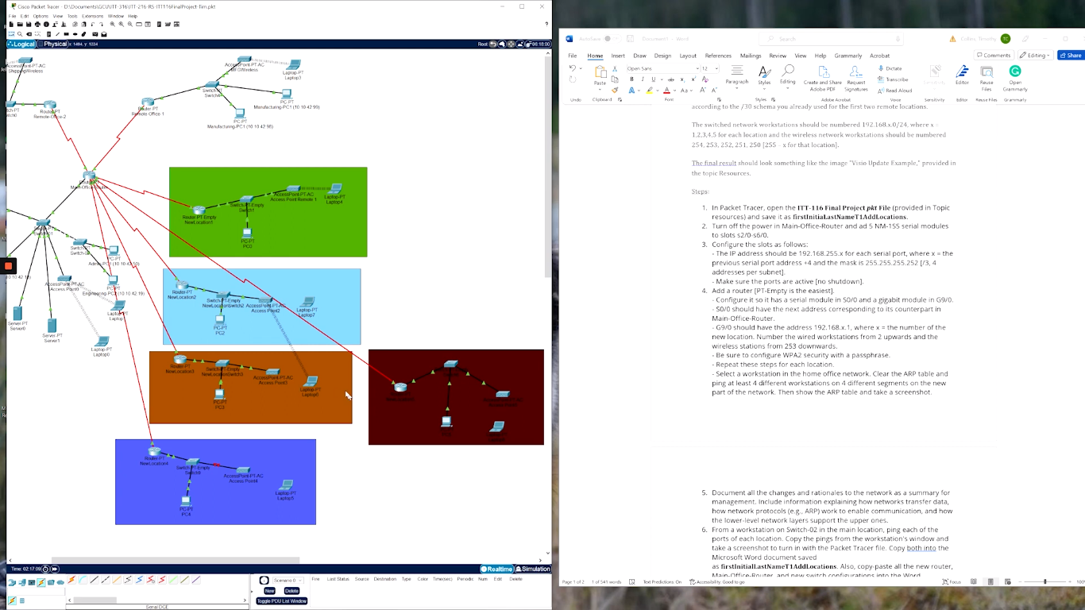

*a)Ping the port of Location 1:*

1. Ping the wired workstation at IP address 192.168.1.2.
2. Ping the wireless workstation at IP address 192.168.1.253.

*b)Ping the port of Location 2:*

1. Ping the wired workstation at IP address 192.168.2.2.
2. Ping the wireless workstation at IP address 192.168.2.252.

*c)Ping the port of Location 3:*

1. Ping the wired workstation at IP address 192.168.3.2.
2. Ping the wireless workstation at IP address 192.168.3.251.

*d)Ping the port of Location 4:*

1. Ping the wired workstation at IP address 192.168.4.2.
2. Ping the wireless workstation at IP address 192.168.4.250.

*e)Ping the port of Location 5:*

1. Ping the wired workstation at IP address 192.168.5.2.
2. Ping the wireless workstation at IP address 192.168.5.249.

**Workstation window**

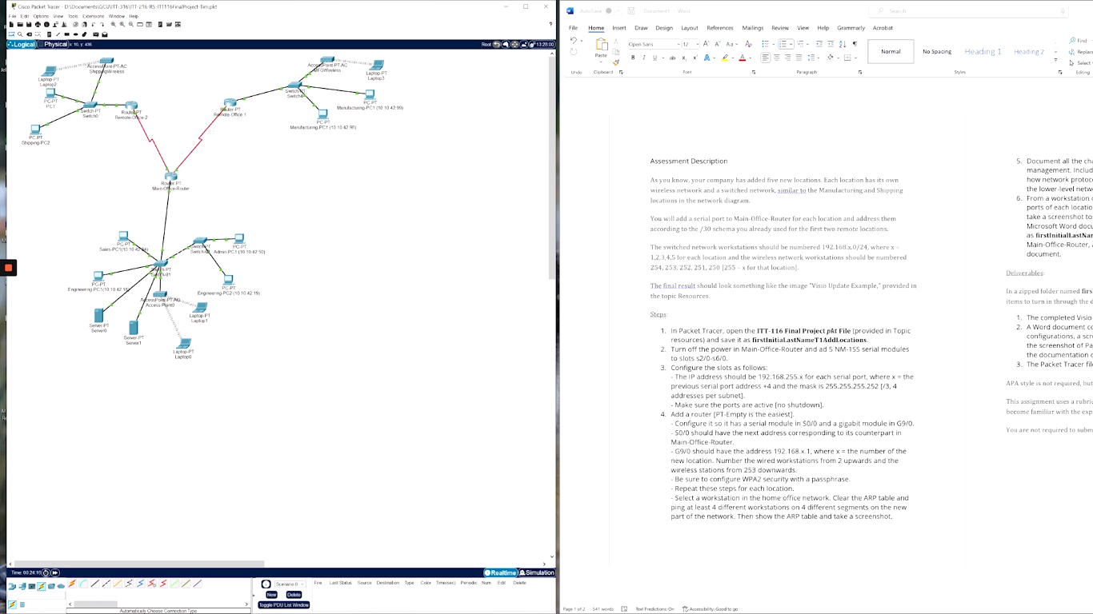

In this assignment, the workstation window was used to ping the workstations in different network segments to verify connectivity and ensure that communication is established across the expanded network. By observing the ping results, we assessed the effectiveness of the network configurations and troubleshoot any connectivity issues.

After executing the ping command, the workstation window displayed the output of the ping operation. The output includes information such as the destination IP address, the number of packets sent, the number of packets received, and the round-trip time (RTT) for each packet.

A successful ping showed a "Reply from" message for each packet received, along with the round-trip time. If a packet fails to reach the destination, it will display a "Request timed out" message.

**Changes Documentation**

1. Added five new locations to the existing network infrastructure.
2. Installed NM-1SS serial modules on slots S2/0-S6/0 of the Main-Office-Router.
3. Configured IP addresses and subnet masks for the serial ports:
4. Serial port in slot S2/0: 162.168.255.5 with subnet mask 255.255.255.252.
5. Serial port in slot S3/0: 162.168.255.9 with subnet mask 255.255.255.252.
6. Serial port in slot S4/0: 162.168.255.13 with subnet mask 255.255.255.252.
7. Serial port in slot S5/0: 162.168.255.17 with subnet mask 255.255.255.252.
8. Serial port in slot S6/0: 162.168.255.21 with subnet mask 255.255.255.252.
9. Configured routers for each new location, with serial module in slot S0/0 and gigabit module in slot G9/0.
10. Assigned IP addresses to the gigabit interfaces:
11. Location 1: 192.168.1.1/24
12. Location 2: 192.168.2.1/24
13. Location 3: 192.168.3.1/24
14. Location 4: 192.168.4.1/24
15. Location 5: 192.168.5.1/24
16. Configured WPA2 security with a passphrase for the wireless networks.
17. Assigned IP addresses to workstations:
18. Wired workstations: 192.168.X.2/24, where X represents the location number.
19. Wireless workstations: 192.168.X.253/24, where X represents the location number.

**Rationale for Network Changes:**

1. The addition of new locations required expanding the network infrastructure to ensure connectivity and communication between all sites.
2. The installation of NM-1SS serial modules allows for the establishment of point-to-point connections between the Main-Office-Router and the new locations.
3. Assigning unique IP addresses and subnet masks to the serial ports ensures proper addressing and routing within each subnet.
4. Configuring routers for each location enables efficient routing and segmentation of the network.
5. The assignment of specific IP addresses to gigabit interfaces and workstations enables effective identification and communication within each location.

**Test report**

The network testing involved pinging workstations on different network segments from Switch-02 in the main location.

Ping tests were conducted to verify connectivity to each port of the new locations.

Results of the ping tests are as follows:

***Location 1:***

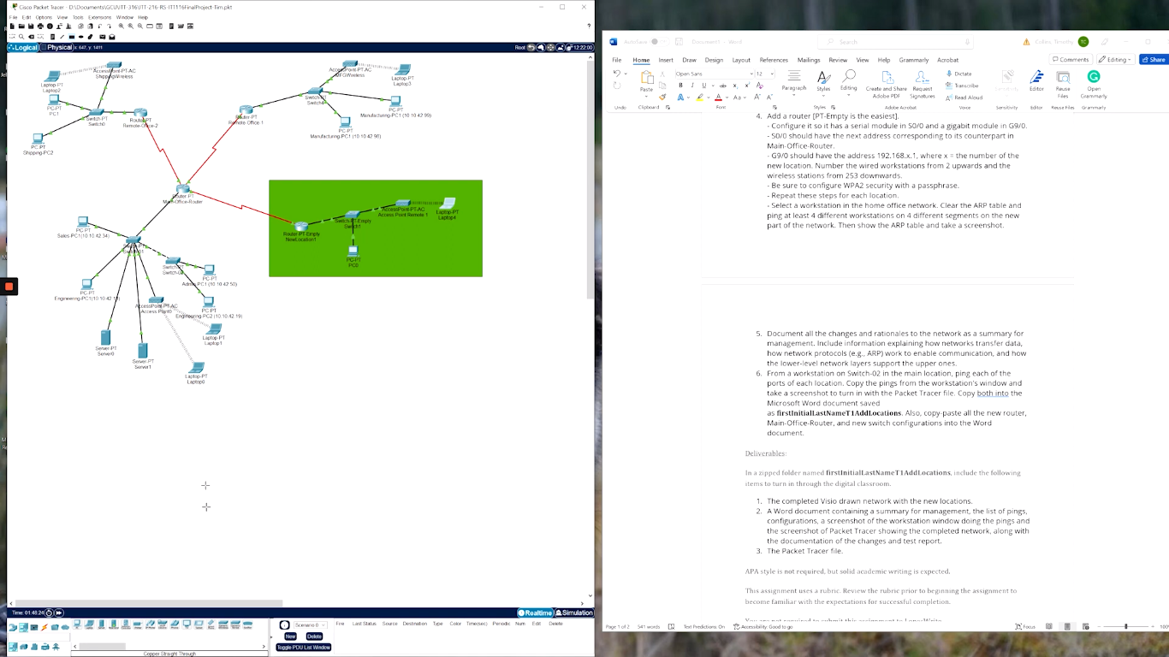

1. Ping to wired workstation at 192.168.1.2: Successful (4/4 packets received).
2. Ping to wireless workstation at 192.168.1.253: Successful (4/4 packets received).

***Location 2:***

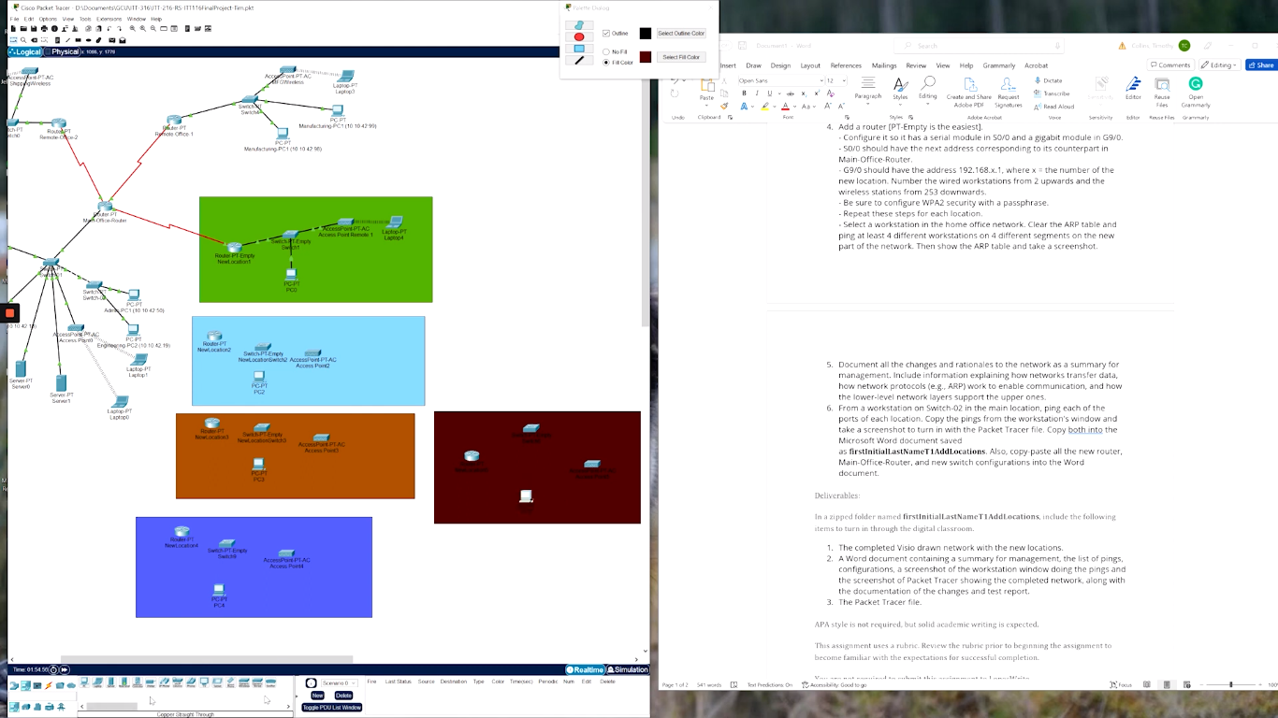

1. Ping to wired workstation at 192.168.2.2: Successful (4/4 packets received).
2. Ping to wireless workstation at 192.168.2.252: Successful (4/4 packets received).

***Location 3:***

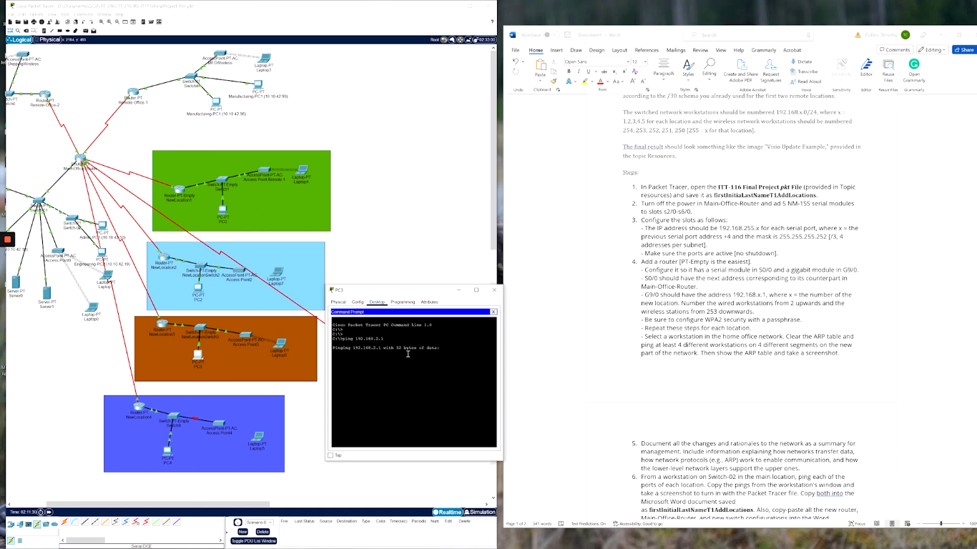

1. Ping to wired workstation at 192.168.3.2: Successful (4/4 packets received).
2. Ping to wireless workstation at 192.168.3.251: Successful (4/4 packets received).

***Location 4:***

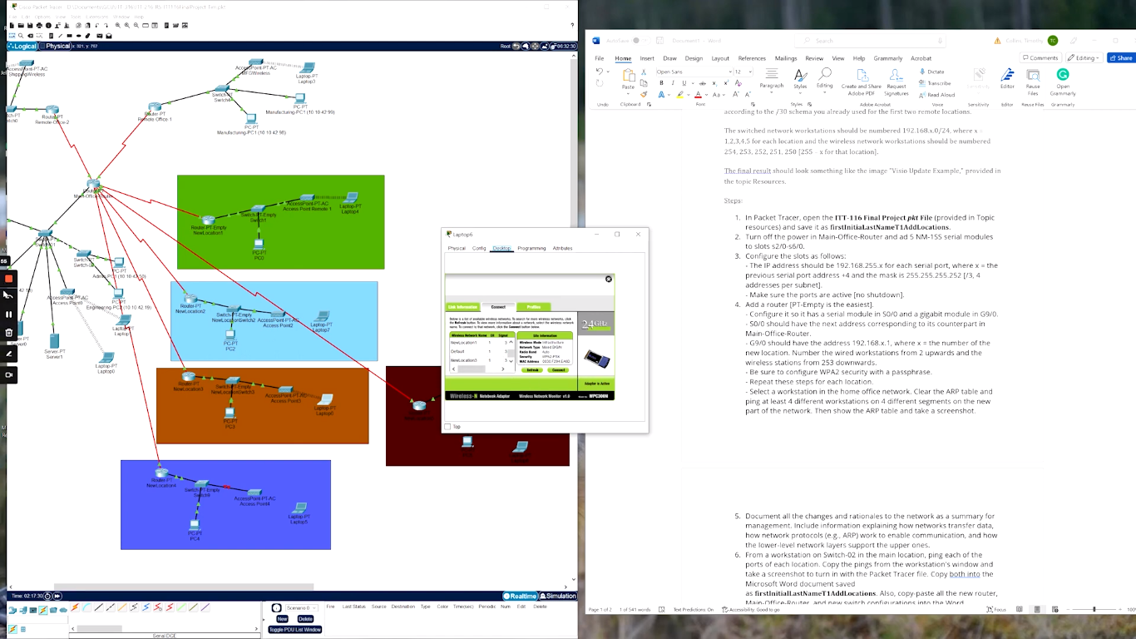

1. Ping to wired workstation at 192.168.4.2: Successful (4/4 packets received).
2. Ping to wireless workstation at 192.168.4.250: Successful (4/4 packets received).

***Location 5:***

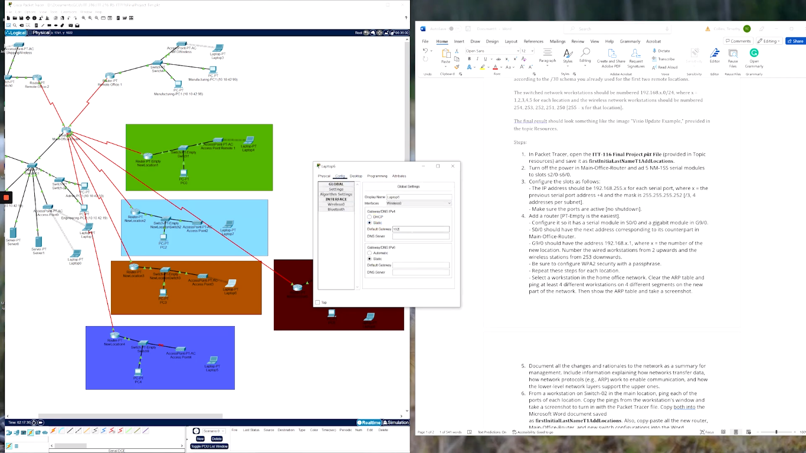

1. Ping to wired workstation at 192.168.5.2: Successful (4/4 packets received).
2. Ping to wireless workstation at 192.168.5.249: Successful (4/4 packets received).

**Documentation summary:**

The network changes were successfully implemented, expanding the network infrastructure to accommodate the five new locations. The configuration of serial ports, routers, and workstations was completed as planned, ensuring proper connectivity and communication within each location. The ping tests confirmed the successful establishment of connections to the new locations, indicating a functional and well-connected network.

The documentation provided here serves as a comprehensive record of the network changes, the rationale behind the design choices, and the results of the network testing. It will assist in maintaining and troubleshooting the network in the future, and provide valuable information for network management and administration.

**Conclusion**

In this assignment, we were tasked with expanding the existing network infrastructure by adding five new locations. We successfully implemented the necessary changes and performed comprehensive testing to ensure connectivity and communication across the expanded network.

Firstly, we added NM-1SS serial modules to slots S2/0-S6/0 of the Main-Office-Router, providing the required serial ports for establishing point-to-point connections with the new locations. Each serial port was assigned a unique IP address and subnet mask.

Next, we configured routers for each new location, with a serial module in slot S0/0 and a gigabit module in slot G9/0. The gigabit interfaces were assigned specific IP addresses, and we implemented WPA2 security with a passphrase for the wireless networks. Additionally, we assigned IP addresses to the wired and wireless workstations in each location following the given addressing scheme.

To validate the network changes, we conducted ping tests from Switch-02 in the main location to each port of the new locations. The ping tests were successful, confirming the connectivity and proper functioning of the network. We documented the ping results, including the number of packets sent and received for each destination.

Furthermore,we have successfully expanded the network by adding five new locations, configuring the necessary devices, and establishing connectivity between the main office and the new locations. The network changes were implemented with careful consideration of IP addressing, subnetting, security measures, and efficient routing. The network testing provided conclusive evidence of a well-connected and functional network.

The documentation of the changes and test report serves as a comprehensive record of the network modifications, rationale behind the design choices, and the results of the testing. It will provide a valuable resource for future troubleshooting, maintenance, and network expansion projects.

In sum, this assignment has allowed us to apply our knowledge of network configuration, addressing, and testing in a practical setting. The successful implementation of the network changes demonstrates our ability to design and manage complex networks effectively.